**COMPARING THE SOCIAL-ECONOMIC FATCORS OF GDP, MOLARITY, IMMUNIZATION ON LIFE EXPECTANCY BASING ON CORRELATIONS**

**AGAINST**

**THE SOCIAL-ECONOMIC FACTORS OF TOTAL EXPENDITURE, ALCOHOL ON LIFE EXPECTANCY BASING ON CORRELATIONS**

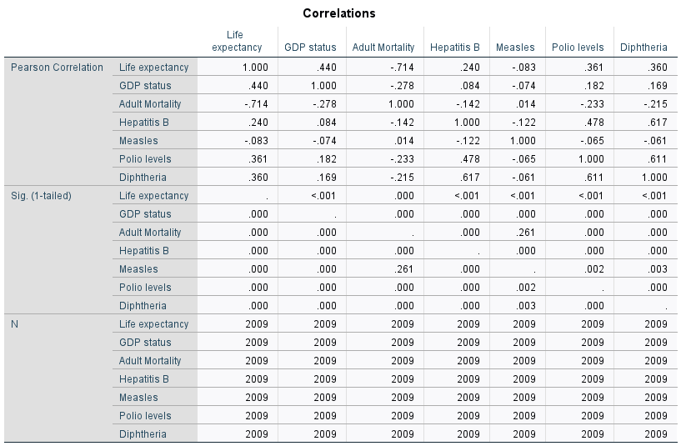

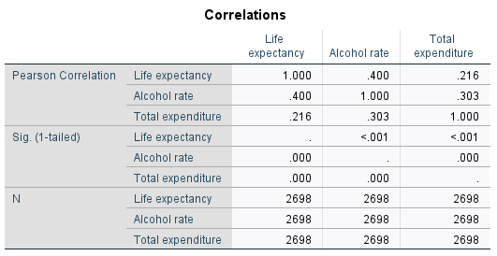

**REPORT SUMMARY ON VALIDATION**

Basing on the first model, the significant predictors affecting the life expectancy where GDP, Hepatitis B, Measles and Polio and the least significant was Adult molarity

While as

Basing on the second model, all predictors(Alcohol, Total expenditure) were affecting life expectancy